**User manual**

Bus Booking App

**Table of Contents**

1. General Information……………………………………………………………………………….….3
   1. Application Overview….……………………………………………………………………3
   2. Organization of the Manual………………………………….………………………….3
2. System Summary………………………….……………………………………………………………3
   1. Hardware and software requirements……………………………………………..3
   2. User Access Levels……………………………………………………………………………4
3. How to download the Application……………………………………………………………..4
   1. github link………………………………………………………………………………………..4

3.2 Google Drive link……………………………………………………………………………..4

1. Installing the Application……………………………………………………………………………4
   1. How to install the application…………………………………………………………..4
   2. Step by step guide to install the App………………………………………………..4
2. Registered users – PRIVILEGES…………………………………………………………………...5
   1. New user registration……………………………………………………………………….5
   2. Login…………………………………………………………………………………………………6
   3. View Schedule……………………………………………………………………………………7
   4. Book bus…………………………………………………………………………………………..8
   5. Edit booking………………………………………………………………………………………8
   6. Cancel/delete booking……………………………….…………………………………….9
   7. Logout…………………………………………………………………………………………….10

**1.0 General Information**

Bus Booking App is associated with FutureArt.com and powered by JayConnect Graphicz

**1.1 Application Overview**

The Bus Booking App is an application made to simplify the needs of students for better use of transport at Campuses.

Bus Booking App is developed and powered by JayConnect Graphics.

**1.2 Organization of the manual**

The user manual consists of the following sessions

1. General information.
2. System Summary.
3. How to download the Application.
4. Registered user – Privilages.

General information section explains in general terms the Bus Booking Application and the section of the user manual.

System summary section explains about the software requirements for accessing Bus Booking App and user access levels.

How to download the Application section explain options available to download the Bus Booking Application.

Using the application section provides a detailed description of the functionalities of the Bus Booking Application.

**2.0 System Summary**

System requirements for installing the Bus Booking Application

**2.1 Software requirements**

This application requires a smart-phone with Android Operating System

Requires Android version 4.4.1 and above

**2.2 User Access Levels**

There is one type of role in Bus Booking Applications

1. Registered user
2. Registered user has to register first in order to access the Bus Booking Application and can then be able to book and managed their booking information.

**3.0 How to download the application**

Bus Booking Application can be download through the link below

**3.1 github link**

On click of the link choose the BusBookingApp.apk file and download

**3.2 google drive link**

On click of the link choose the BusBookingApp.apk file and download the app

**4.0 Installing the application**

Once download click on the BusBookingSystem.apk file

**4.2 Step by step guide to install the App**

Click install app and the click install anyway when prompted by the play protect popup.

Press done when finished installing and the click open.

**5.0 Registered User - PRIVILAGES**

**Registration Page**

You will have to register first for

the first time when using the application.

You will provide your Email and password

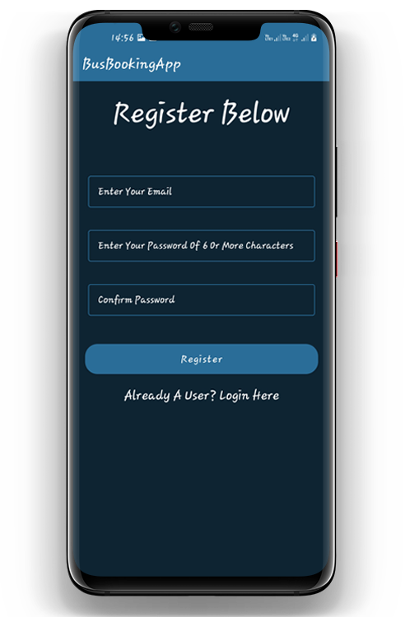

You will be directed to the Home page where you will be provided with the following :

1. Your Booking Schedule
2. A FAB button option to add new booking
3. An option to Log out

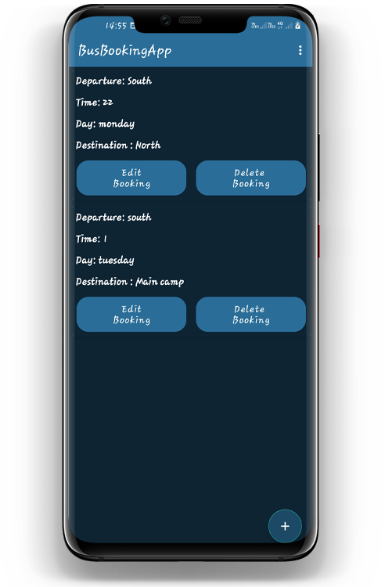

**Home Page** gives you access to the Bus Schedule and an option to add a new booking schedule. As a registered user, you are also given an option to edit and delete your booking schedule, and also gives you the option to logout. All your bookings are well organized for easy access.



You are also given an option to delete and edit your booking information at of the already booked buses of your choosing. At the end you will be notified when the bus is full.

**The FAB button option** allows you to add new bookings to your bus schedule. You have access to view and manage your bookings.

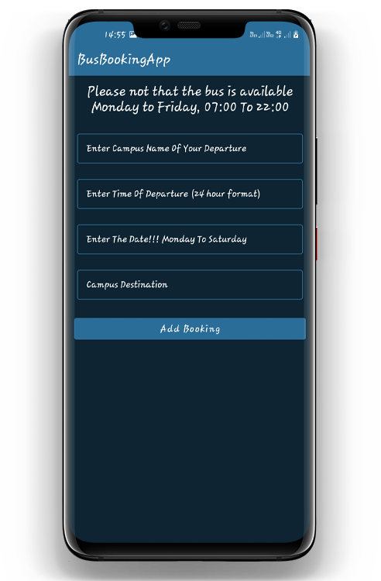

**The Logout Option** allows a user to logout of the App.

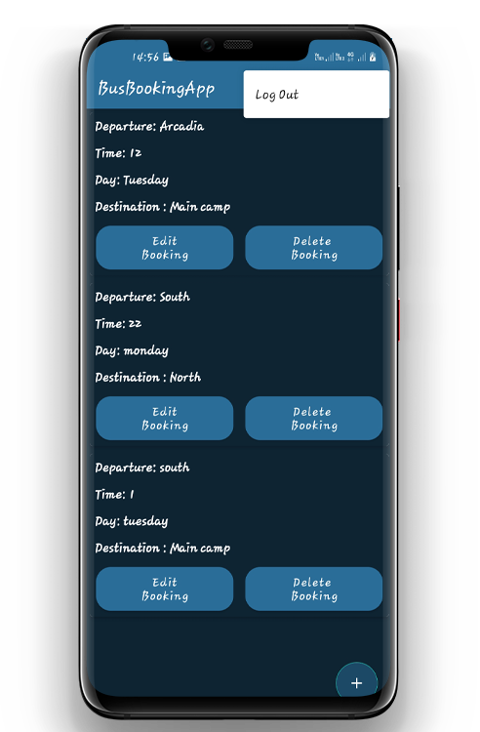

**On Logout**

In case you decide to logout, next time you decide to open the app again you will not be prompted to register again but you will taken to your Schedules.

